* PUT /books/{isbn}: as we will create a book with manually setting the {isbn}
* GET /books/{isbn}: get a single book.
* GET /books: get all books.
* PUT /books/{isbn}: update the entire book (Full Update)
* PATCH /books/{isbn}: update the only fields which are present in the request body. (Partial Update)
* DELETE /books/{isbn}: delete a single book.

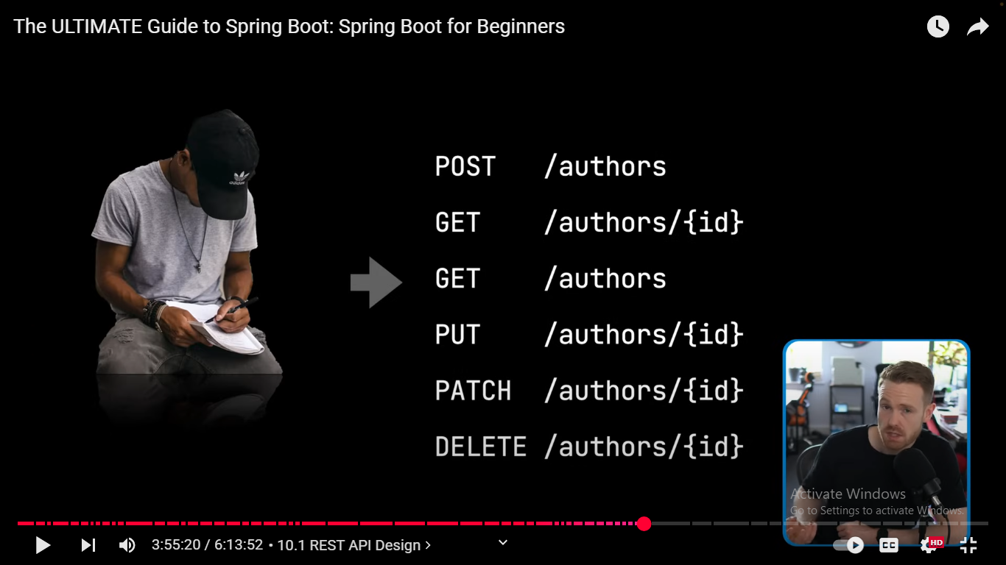

* POST /authors: create a author with setting the {id} from the table schema.
* GET / authors /{id}: get a single author.
* GET / authors: get all authors.
* PUT / authors /{id}: update the entire author (Full Update)
* PATCH / authors /{id}: update the only fields which are present in the request body. (Partial Update)
* DELETE / authors /{id}: delete a single author.